
Company
Logotype

Cone Beam Computed Tomography- Report



Porur Dental X-rays & CBCT

Patient Name : Mr. Sankar | Date of Report : 01.07.2024
Age/ Gender : 18 years/ Male | Region of Interest : CBCT Maxilla
Referring doctor: 32 Dental Care | Indication : Impacted teeth
Clinical Notes: Nil
PATIENT INFORMATION

CBCT Maxilla provided
CBCT – IMAGE DETAILS

RADIOGRAPHIC INTERPRETATION

- Deciduous teeth present in the anterior maxillary region: 53, 63, 65.
- The tooth 13 appears to be within the alveolar bone, distally tipped with its crown near the radicular portion of 53 and root of 13 in proximity to the medial wall of right maxillary sinus and floor of nasal cavity.
- The tooth 23 appears to be within the alveolar bone, distally tipped with its crown near the radicular portion of 63 and root of 23 in proximity to the medial wall of left maxillary sinus and floor of nasal cavity.
- The tooth 23 is positioned such that it involves the labial cortical bone.

RADIOGRAPHIC IMPRESSION


- Impacted teeth: 13, 23.
- Retained deciduous teeth: 53, 63, 65.

IMAGES FOR REFERENCE

RECONSTRUCTED PANORAMIC VIEW
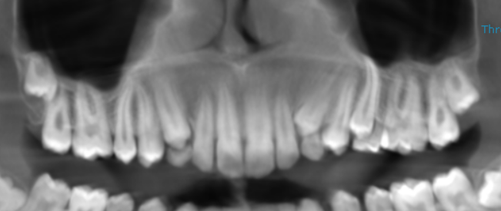

3-DIMENSIONAL VIEW

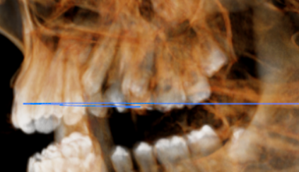
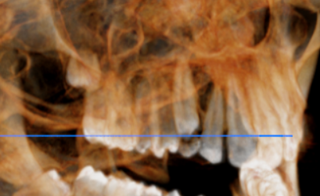
13 REGION | 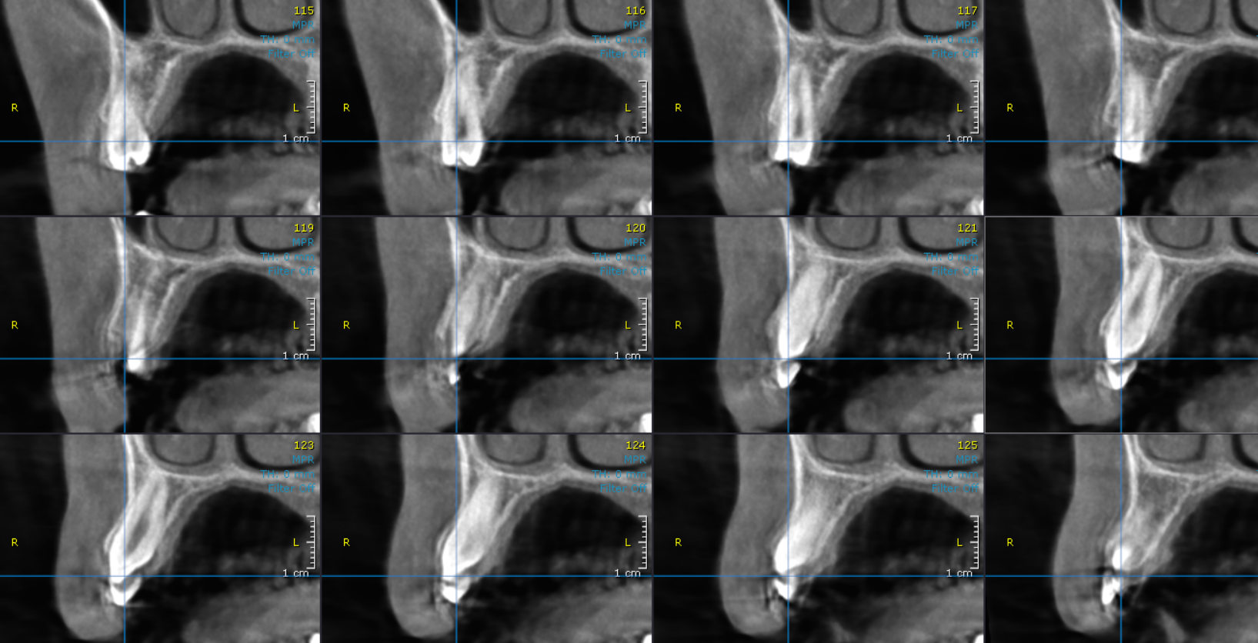
23 REGION | 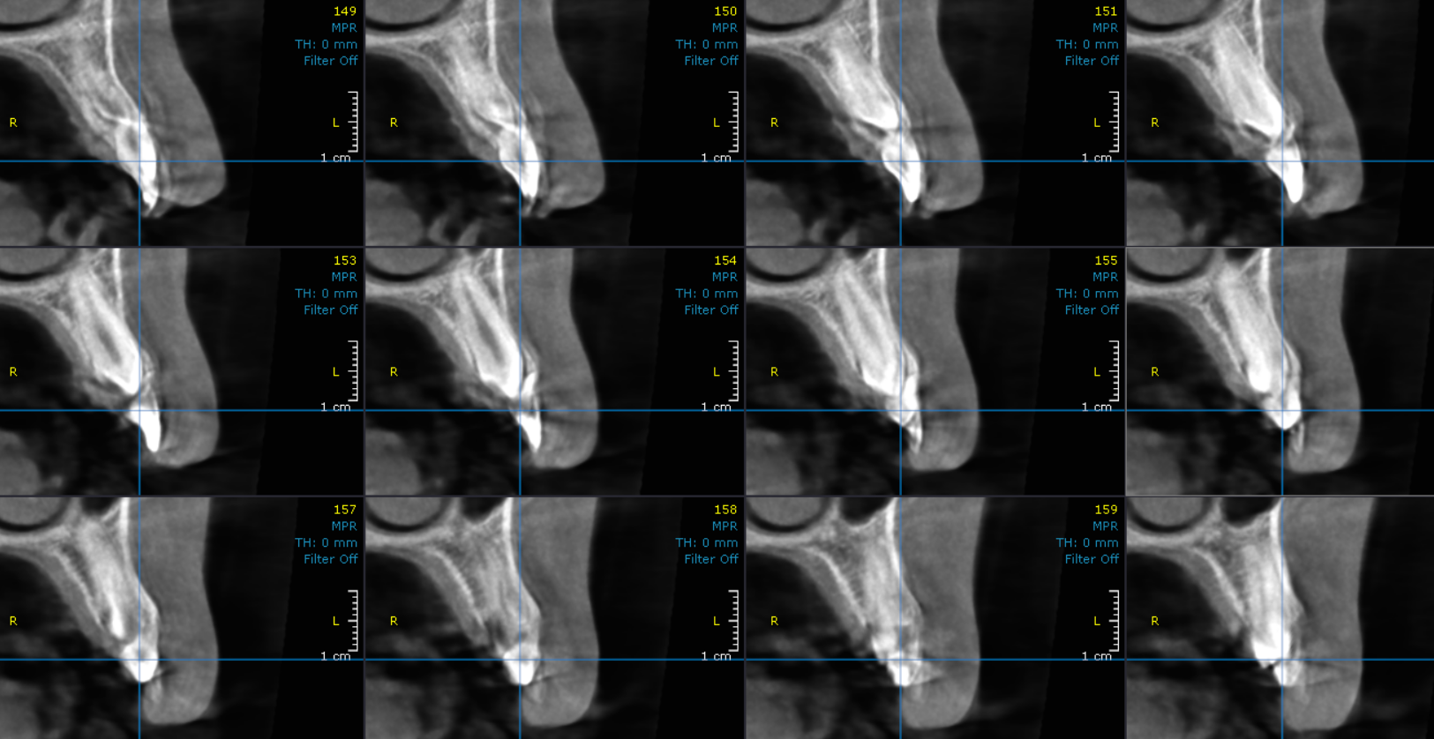
CROSS- SECTIONAL IMAGES

**** End of report ****

